**WQD7001 GROUP PROJECT**

**Initial / ~~Final~~**

You are representing which group? 4

State the Number of your group as registered on Google doc 4

State the leader name Muhammad Shakyr Bin Rosman

1. What is the domain of interest you are working on?

Commercial consumer good

1. Why are you personally interested in this domain of your project?

We think that searching for a car is a daunting task. So, this shiny app will ease the process in recommending a type of car to purchase.

1. What question(s) are you asking?

What are customers preferences when buying used cars?

Given the preferences of customers, what types of cars can be considered?

1. For whom are you answering the question being asked? Name the beneficiary of the product.

Potential customers looking to purchase a second-hand vehicle.

1. Do you refer to the data science process to carry out this project? Yes/No If yes, which one?

Justify in few words: Yes, the data science process is used.

1. Identified the problem
2. Collected the raw data
3. Processed the data for analysis
4. Next, we will explore the data
5. An in-depth analysis will be performed
6. The results will be communicated through the creation of a shiny app
7. What data are you using? State the source.

Used-car dataset: https://www.kaggle.com/datasets/austinreese/craigslist-carstrucks-data

1. What kind of analysis are you doing?

Exploratory data analysis

1. Do you consider your results significant? Briefly explain.

The results can be used to help narrow down the choices that a customer might have to consider when purchasing a used-car.

1. What is your data product?

Used-Car recommender

Describe the *Design Thinking* element that you incorporate in your project. 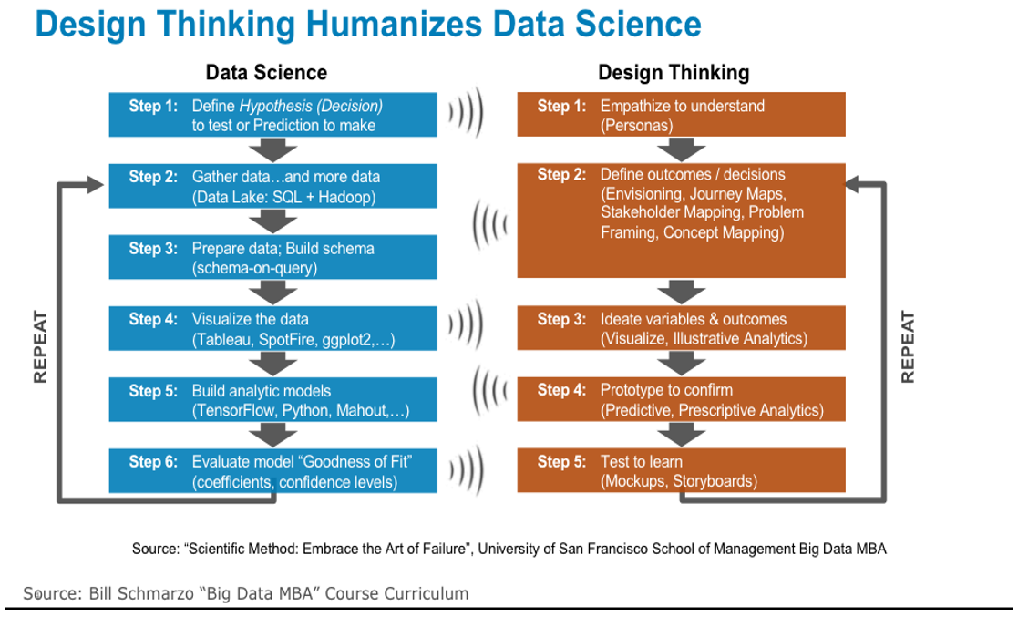

The design thinking process used to create a data product which is useful for potential used-car purchasers. According to the raw-data collected, new attributes can be created from the observations. This helps in the generation of creative ideas for a shiny app using the available dataset. Then, from exploratory data analysis, observations can be made to fine-tune those ideas. This process can be repeated infinitely until a satisfactory result is achieved.

1. (Final submission only) Did you consider “reproducibility” in your work? Show evidence.

N/A